Feature Request: Hook Search

**September 8th 2018**

**OBJECTIVE**

Users can easily trigger a search when pressing the enter key.

**BACKGROUND**

Currently, Jammming supports the ability to search only when users click the search button on the website, which is not convenient for easy browsing. Most search engines and entertainment websites enable users to search through the enter key. As a user-friendly web application, hook up components to search when users hit enter is the key functionality to support.

**TECHNICAL DESIGN**

New component:

In SearchBar.js, create a new method named handleEnterKey. This method should include event as a parameter. When user hit the enter key, it should trigger the search method. The following screenshot shows an expected demo.

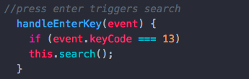

Figure1: HandleEnterKey Method

Existing component updates:

In SearchBar.js, the SearchBar component constructor should be updated. We need to bind the new HandleEnterKey method. Also, in the render method, an attribute should be added to the input. The following screenshots explain the updates.

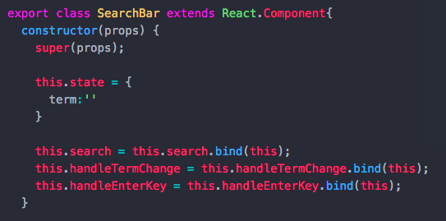

Figure2: Updating Constructor Method

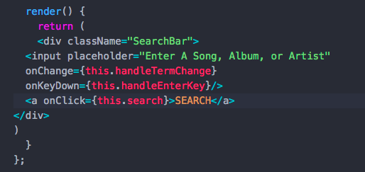

Figure3: Updating Render Method

**CAVEATS**

Alternative solution:

Developers can make a new file named HandleEnterKey, and export it to SearchBar.js. However, there is no need to do so.